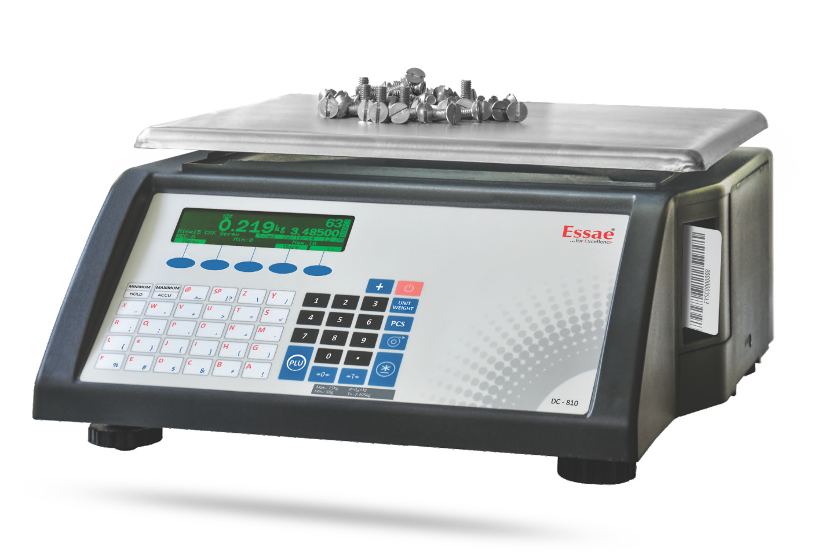













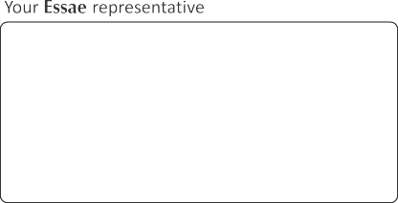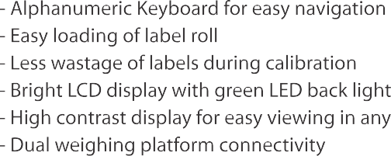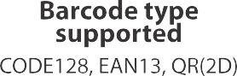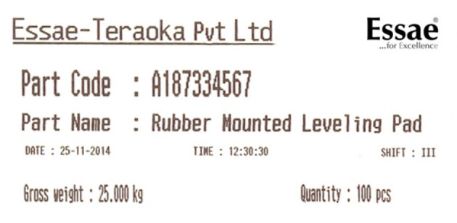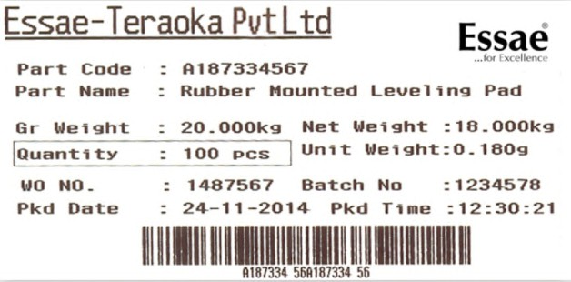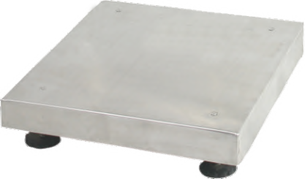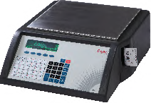

NATARAJ ELECTRONICS 9341625011

93416250

903535459

NATARAJ ELECTRONICS



            
            
       
            
            
            
            
            

    
    
    
    
    
    
    
    
    
    
    